NOTICE OF BID INVITATION: DEPARTMENT OF CORRECTIONAL SERVICES
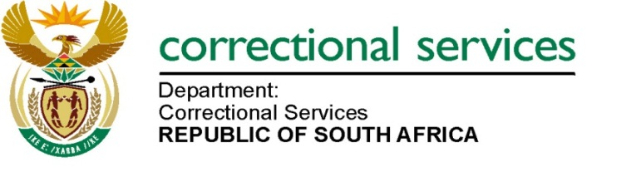
DEPARTMENT OF CORRECTIONAL SERVICES
NEW BID INVITATION
BID NUMBER | DESCRIPTION | PPPFA CRITERIA | PUBLISHING DATE | Non-Compulsory BRIEFING SESSION | CLOSING DATE
BID HO 1/2024 | HO 1/2024: APPOINTMENT OF A SERVICE PROVIDER (S) FOR SUPPLY, DELIVERY AND OFF LOADING OF FERTILIZER TO VARIOUS CORRECTIONAL CENTRE FARMS FOR THE PERIOD OF THS THREE (3) YEARS: DEPARTMENT OF CORRECTIONAL SERVICES | 90/10 | 18/04/2024 | 25 April 2024 at 09:00 AM | 28/05/2024
Contact details: 012 305 8268

NON-COMPULSORY BRIEFING SESSION

Bidders must take note of the Non-compulsory briefing session that will take place on 25 April 2024 at 09:00 on virtual meeting.

Link:

https://teams.microsoft.com/l/meetup-join/19%3ameeting_ZDhjNzUzYzUtNTU4OC00MTBjLTk3NzEtNTcyNDlmMzE0OGEw%40thread.v2/0?context=%7b%22Tid%22%3a%2268026d69-ab70-4d46-a3e0-6edad467e5fd%22%2c%22Oid%22%3a%220ed7c0a9-829b-483a-b751-eed05c51c275%22%7d

Microsoft Teams

Join the meeting now
Meeting ID: 318 613 192 956
Passcode: qSCgw3

Notes: Bid documents can also be downloaded for free on http://www.etenders.gov.za/content/advertised-tenders

And http://wwww.dcs.gov.za
- Opportunities-
- tenders bid
- advertised

