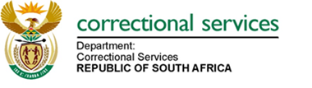
NOTICE OF BID CANCELLATION: DEPARTMENT OF CORRECTIONAL SERVICES
NOTICE IS HEREBY GIVEN TO ALL PROSPECTIVE SERVICE PROVIDERS/BIDDERS THAT THE FOLLOWING BID HAS BEEN CANCELLED.
BID NUNBER: | BID DESCRIPTION
BID HO 4/2020 | SUPPLY, DELIVERY AND OFF-LOADING OF NUTRITIONAL PRODUCTS (PERISHABLE PROVISIONS/ NON-PERISHABLE PROVISIONS) TO THE DEPARTMENT OF CORRECTIONAL SERVICES FOR THE PERIOD OF FIVE (5) YEARS: DEPARTMENT OF CORRECTIONAL SERVICES.
REASON | THE DEPARTMENT HAS IMPLEMENTED SELF-SUFFICIENCY STRATEGY TO SOURCE PRODUCTS

