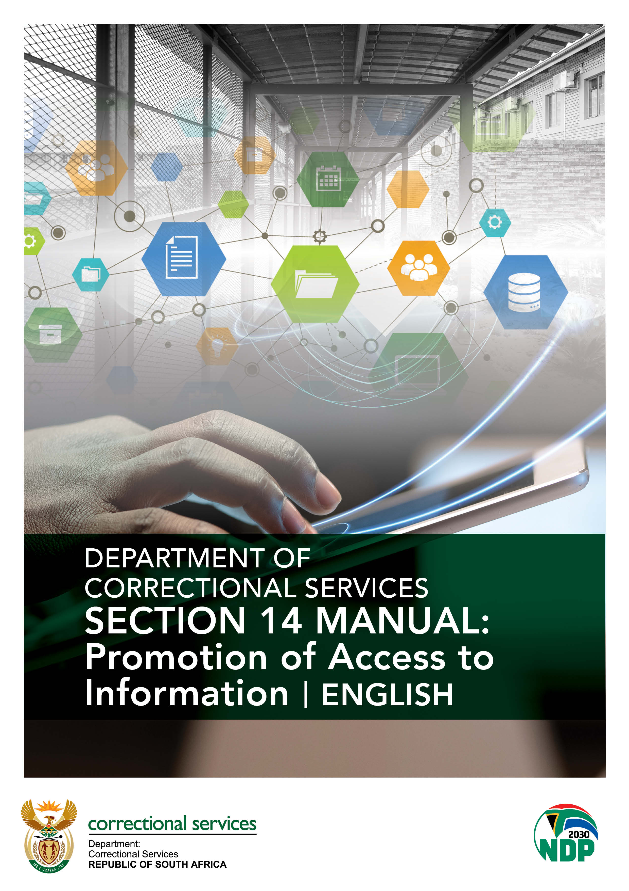

**SECTION 14 MANUAL:**

**PROMOTION OF ACCESS TO INFORMATION**

**(English)**

**PAIA UNIT CONTACT DETAILS**

**PAIA COORDINATOR**

Vacant

TEL: (012) 305 8234

FAX: (012) 326 1564

**DEPUTY DIRECTOR: RECORDS MANAGER**

MS R. KHOZA

TEL: (012) 305 8633

FAX: (012) 326 1564

EMAIL: [robyn.khoza@dcs.gov.za](mailto:robyn.khoza@dcs.gov.za)

**DC: POLICY COORDINATION AND RESEARCH (ACTING)**

MR S ZIKALALA

TEL: (012) 307 2274

FAX: (012) 321 0283

EMAIL: [sihle.zikalal@dcs.gov.za](mailto:sihle.zikalal@dcs.gov.za)

**CONTENTS**

Definitions 1

Introduction 1

Mandate of the Department of Correctional services 1

DCS Organogram 1

Function of branched of the Department of Correctional Services 1

Information Officer and Deputy Information Officer 1

Guide on how to use PAIA 1

Records held by the Department of Correctional Services 1

Request procedure 1

Records automatically available 1

Prescribed fees of a public body 1

Description of all remedies available in respect of an Act or failure to act by the body 1

Services available to members of the public and how to gain access to those services 1

Public involvement 1

Performance of duties by DCS 1

Purpose for processing of personal information 1

Planned transborder flow of personal information 1

General description of information security measures to be implemented by DCS to ensure the confidentiality, integrity and availability of the information 1

Updating the manual 1

Annexure A Form 1: Copy of the guide 1

Annexure B Form 2: Access to record 1

Annexure C form 3: Outcome of request 1

Annexure D form 4: Internal appeal 1

**SECTION 1**

DEFINITIONS

|  |  |
| --- | --- |
| **ITEM** | **DESCRIPTION** |
| **ACCESS FEE** | The access fee is paid by the requestor to the body from which you are requesting the information, to cover of finding and copying the records you require. |
| **AUTHORISED PERSON** | Is the Person who is making a request on behalf of someone else, and who has been properly authorised to do so. |
| **DIO** | Deputy Information Officer. |
| **DCS** | Department of Correctional Services. |
| **DATA SUBJECT** | The person to whom personal information relates. |
| **GUIDE** | A book produced by Human Rights Commissionin terms of Section 10 of PAIA for reasonably assisting a person who wishes to exercise any right in terms of PAIA. |
| **IO** | Information Officer. |
| **MINISTER** | Minister of Justice and Correctional Services. |
| **PAIA** | Promotion of Access to Information Act No. 2 of 2000 (as Amended). |
| **POPIA** | Protection of Personal Information Act No.4 of 2013. |
| **REGULATIONS** | Regulations that supplement the Act which must be published in the Gazette. |
| **REGULATOR** | Information Regulator established in terms of section 39 of POPIA |
| **REPUBLIC** | Republic of South Africa. |
| **RESPONSIBLE PARTY** | Means a public or private body or any other person which, alone or conjunction with others, determines the purpose of and means for processing personal information. |
| **RECORD** | means any recorded information**-**   * regardless of form or medium; * in the possession or under the control of a public or private body irrespectively; and * whether or not was created by that public or private body irrespectively. |
| **RELEVANT AUTHORITY** | In relation to records requested from DCS, means the Minister of Justice and Correctional Services (the Minister). |
| **SAHRC** | South African Human Rights Commission. |

**SECTION 2**

INTRODUCTION

The Promotion of Access to Information 2000, as amended, (the Act), gives third parties the right to approach public bodies to request information held by them, which is required in the exercise and or protection of any rights.

Section 14 of the manual prescribes that a Public body must compile a manual providing details of the Information Officer, and (Deputies where available), structure, functions and records of the Body.

This manual informs the requestor of procedural and other requirements which a request must fulfil as prescribed by the Act, and further incorporates the requirements of the Protection of Personal Information Act, 2013 POPIA.

On request the public body is obliged to release such information unless the Act expressly states that the records containing such information may or may not be released.

**SECTION 3**

MANDATE OF THE DEPARTMENT OF CORRECTIONAL SERVICES

Section 184 of the Constitution of the Republic of South Africa Act (No 108 of 1996) lays the basis for the mandate of the Department of Correctional Services (DCS). The Constitution mandates the Department to comply with the following sections in terms of the treatment of offenders.

**Constitutional Mandates**

The Constitution compels the department to comply with the following sections in terms of the treatment of offenders:

* Section 9 - Equality
* Section 10 Human dignity
* Section 12 Freedom and security of the person
* Section 27 Right to health care services
* Section 28 Children’s rights
* Section 29 Right to education
* Section 31 Freedom of religion
* Section 35 Rights to humane treatment and to communicate and be visited by family, next

of kin etc.

* Section 36 Limitation of rights

**Legislative Mandates**

Correctional Services Act (No.111 of 1998) as amended provides for a correctional system which details the establishment, functions and control of the Department of Correctional Services. The Correctional Services is responsible for the following amongst others:

* Custody of all offenders under conditions of human dignity;
* The rights and obligations of unsentenced offenders;
* A system of community corrections;
* Release from correctional centres and placement under correctional supervision,
* One day parole and parole;
* A National Council for Correctional Services;
* A Judicial Inspectorate; and internal service evaluation;
* Officials of the Department;
* Independent Correctional Centre Visitors;
* Joint venture correctional facilities;
* Penalties for offences;
* The repeal and amendment of certain laws; and matters connected therewith.

**Criminal Procedure Act, (Act No. 51 of 1997)**

Section 63A, Chapter 28, and Section 299A of the CPA provides for a procedure that a Court order release of certain accused on warning, bail, bail conditions at the direction of the Head of Correctional Centre if not opposed by the Director of Public Prosecutions.

It provides for Protocols within the Justice Crime Prevention Services cluster to encourage assisting accused persons who do not pause a danger to society to be released from detention even though they cannot afford the bail set by the court.

**Child Justice Act, (Act No.75 of 2008)**

The Child Justice Act creates a rights-based approach to managing children accused of the committing crime within the Justice system. It provides for freedoms through use of diversion, alternative sentencing and restorative justice, prevent crime and promote public safety.

**Compensation for Occupational Injuries and Diseases Act, (Act No. 75, of 2008;**

Provides for compensation for disablement caused occupational injuries or diseases, sustained or contracted by employees during their employment or death resulting from such injuries or diseases, and to provide for matters there with.

**COVID-19 Direction on Health and Safety in the Workplace issued by the Minister in terms of Regulation 10(8) of the National Disaster Regulations**

The Occupational Health and Safety Act (OHSA), read with its regulations and incorporated standards, requires the employer to provide and maintain as far as is reasonably practicable a working environment that is safe and without risks to the health of workers and to take such steps as may be reasonably practicable to eliminate or mitigate the hazard or potential hazard. OHSA requires employers to review and update risk assessments on a regular basis. The objective of conducting or updating a risk assessment in respect of COVID-19 is to provide specific focus on COVID-19 and adapt the measures required by directives been issued to specific working environments considering the Risk Assessment Guides published by the National Department of Health.

**Employment Equity Act, (Act No. 55 of 1998)**

This Act aims to promote the constitutional right of equality and the exercise of true democracy. Its aim is to eliminate unfair discrimination in employment, redress the effects of discrimination, achieve a diverse workforce broadly representative of our people, promote economic development and efficiency in the workforce and give effect to the obligations of the Republic as a member of the International Labour Organisation.

**Labour Relations Act, (Act No. 66 of 1995)**

The purpose of this Act is to advance economic development, social justice, labour peace and the democratisation of the workplace by fulfilling the primary objects of this Act, which are, amongst others-

1. to provide a framework within which employees and their trade unions, employers and employers' organisations can-
2. collectively bargain to determine wages, terms and conditions of employment and other matters of mutual interest; and
3. formulate industrial policy; and (d) to promote- (i) orderly collective bargaining; (ii) collective bargaining at sectoral level;
4. employee participation in decision-making in the workplace; and (iv) the effective resolution of labour disputes.

**National Health Act (Act No. 61 of 2003)**

This provides for uniform, quality health systems ensuring that all citizens are provided with medical treatment and a right to an environment that is not harmful to their health. This right extends to all inmates as well as Citizens.

**Occupational Health and Safety Act, (Act No. 85 of 1993)**

The main objective of the Act could be described as a pro-active attempt by government to prevent and avoid work related injuries and illness. The Act governs the health and safety for the diverse industry of South Africa. It regulates and control health and safety in all organisations, from a normal office environment to more hazardous environments.

**Prevention and Combating of Torture of Persons Act, (Act No. 13 of 2013)**

This Act protects everyone from all forms of torture by the state, ensuring that all inmates held in custody by the state are safe. Torture is a criminal offence.

**Promotion of Access to Information Act, (Act No. 2 of 2000)**

To give effect to the constitutional right of access to information held by the state, and any information that is held by another person and that is required for the exercise or protection of any rights and provide for matters connected herewith.

**Promotion of Administrative Justice Act, (Act No. 3 of 2000)**

Provides citizens with the right to just administration through promotion of appropriate principles.

**Promotion of Equality and Prevention of Unfair Discrimination Act, (Act No. 4 of 2000)**

The consolidation of democracy in South Africa requires eradication of social and economic inequalities that are systemic in nature and were generated through historic measures of colonialism, apartheid and patriarchy.

The purpose of this Act is to prevent and prohibit unfair discrimination and harassment, to promote equality and eliminate unfair discrimination, to prevent and prohibit hate speech, and to provide and provide for matters connected herewith.

**Protection of Personal Information Act, (Act No. 4 of 2013)**

This is to protect personal information of citizens, striking a balance between right to privacy and the need for free flow and access to information.

**Public Service Act, (Act No 103 of 1994)**

Provides for the organisation and administration of the public service of the Republic, the regulation of the conditions of employment, terms of office, discipline, retirement and discharge of members of the public service, and matters connected therewith. Critical to this strategy is chapter 15 of the PSA 103 of 1994 with respect to transfer of employees.

**Skills Development Act, (Act No. 97 of 1998)**

The Skills Development Act aims to expand the knowledge and competencies of the labour force in order to improve productivity and employment. The Main Aims of the Act are: To improve the quality of life of workers, their prospects of work and labour mobility, to improve productivity in the workplace and the competitiveness of employers and to improve the delivery of services of the department.

**The Mental Health Act, (Act No. 17 of 2002)**

This provides for regulation of mental health care ensuring that the best possible treatment and rehabilitation services are provided to all citizens.

**SECTION 4**

**VISION MISSION AND VALUES OF THE DEPARTMENT OF CORRECTIONAL SERVICES**

**Vision**

Providing the best Correctional Services for a safer South Africa

**Mission**

Contributing to a just, peaceful and safer South Africa through effective and humane incarceration of inmates and the rehabilitation and social reintegration of offenders

**Values**

***Development***

* Enablement and empowerment
* Faith in the potential of people
* Provision of opportunities and facilities for growth

***Integrity***

* Honesty
* Disassociation form all forms of corruption and unethical conduct
* Sound business practices

***Effectiveness***

* Productivity
* The best work method
* Excellent services

***Ubuntu***

* Serving with kindness and humanity

***Accountability***

* Desiring to perform well
* Accepting accountability for your behaviour
* Commitment

***Justice***

* Fair treatment
* Justice for all
* Fairness and equality before the law

***Security***

* Safety of employees, inmates and the community

***Equity***

* Non-discrimination
* Affirmative action
* Gender equality
* Integration of disability issues

**SECTION 5**

DCS ORGANOGRAM

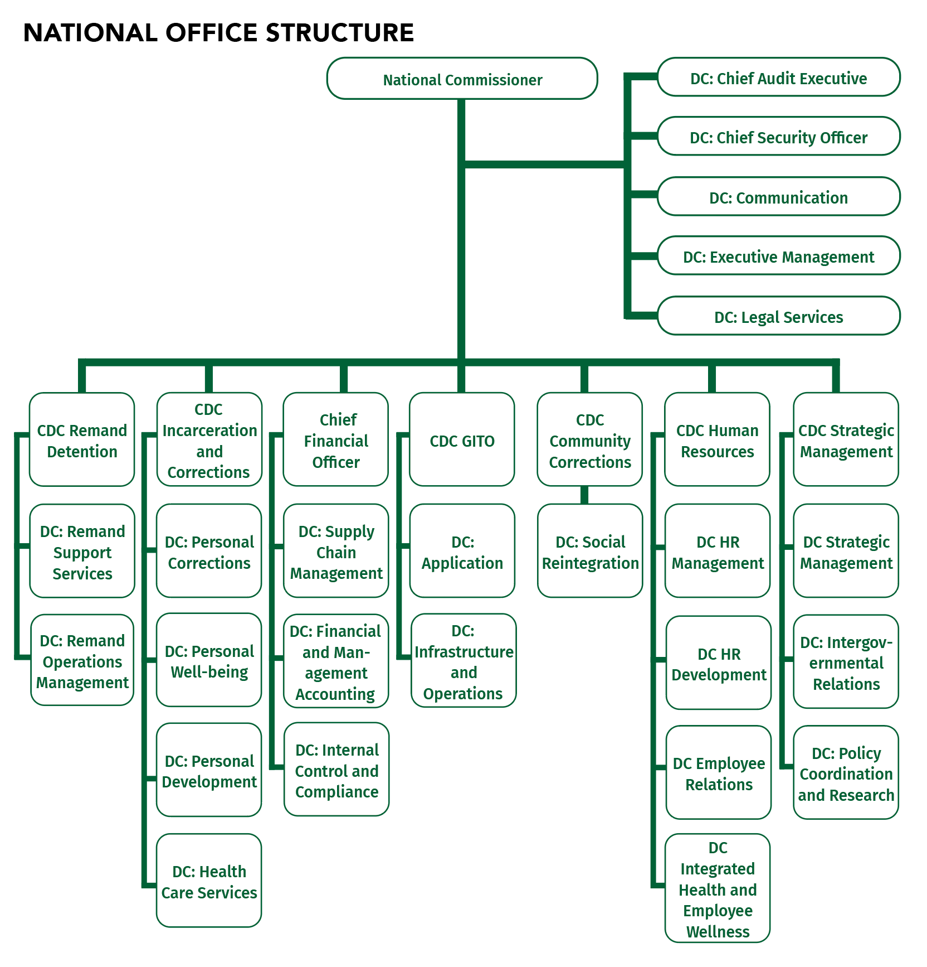

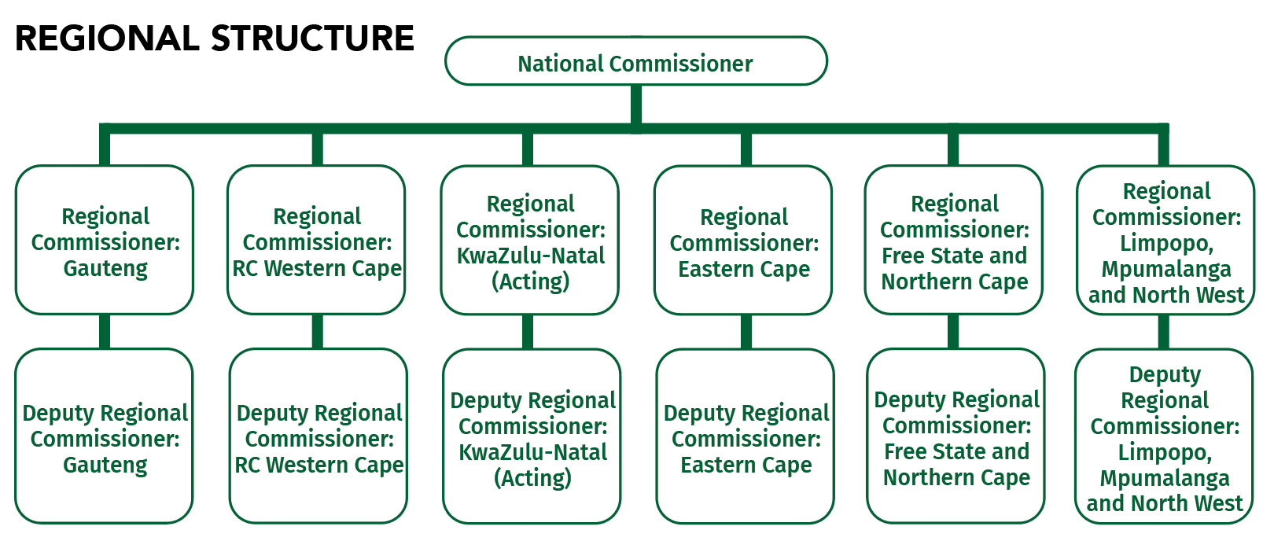

**SECTION 6**

FUNCTION OF BRANCHES OF THE DEPARTMENT OF CORRECTIONAL SERVICES

|  |
| --- |
| **EXECUTIVE MANAGEMENT** |
| The objectives of the chief-directorate are to provide effective and efficient administration functions and the implantation of control measures as well as providing oversight over operational functions at Head Office level and resides directly under the National Commissioner. |
| **COMMUNICATIONS** |
| The objectives of the chief-directorate are to provide internal communication and media production services and effective communication strategies through public education, stakeholder relations, marketing and promotions and resides directly under the National Commissioner. |
| **CHIEF AUDIT EXECUTIVE** |
| The objective of the chief-directorate is to provide effective internal and specialized auditing functions and the management of audits by implementing effective control measures at Head Office and Regional level and resides directly under the National Commissioner. |
| **INCARCERATION AND CORRECTIONS** |
| The objectives of the branch are to provide services and programs aimed at fulfilling basic needs in order to develop maintain and enhance the offender’s well-being as well as through nurturing of the intellectual, social, emotional, spiritual, and physical components by means of specific programs aimed at ensure the realization of the offender’s full potential. The branch comprises of six chief-directorates namely; Personal Corrections; Personal Well-being, Personal Development, Security, Health Care Services and Facilities Planning and Property Management. |
| **REMAND DETENTION** |
| The objectives of the branch are to provide effective and efficient management of remand detention by carrying out court decisions and accommodation of remand detainees in safe and secure facilities consistent with a Human Rights environment. The branch comprises of two chief-directorates namely; Support Services and Operations Management. |
| **COMMUNITY CORRECTIONS (SOCIAL RE-INTERGRATION)** |
| The objectives of the branch are to provide management corrections administration, correctional programmes and risk profiling of offenders. The branch comprises of one chief-directorate namely; Social Re-integration. |
| **HUMAN RESOURCE** |
| The objectives of the branch are to improve human resource capacity & management capacity to enable the department to fulfil its mandate. The branch comprises of four chief-directorates namely; Human Resource Management; Human Resource Development; Integrated Health and Employee Wellness and Employee Relations. |
| **STRATEGIC MANAGEMENT** |
| The objectives of the branch are to provide strategic, administrative and technical management support to the office of the National Commissioner with respect to his overall responsibilities regarding the activities of the department. The branch comprises of three chief-directorates namely; Strategic Management; Intergovernmental Relations and Policy Coordination and Research. |
| **FINANCE** |
| The objectives of the branch are to provide effective and efficient financial management, accounting and supply chain services and to improve organizational compliance with legislation, policies and procedures. The branch comprises of three chief-directorates namely; Internal control and compliance; Supply Chain Management and Financial Management Accounting. |
| **GITO** |
| The objectives of the branch are to provide a secured ICT infrastructure and business systems to enhance service delivery. The branch comprises of two chief-directorates namely; Applications Management, IT Portfolio and Programme Management and Infrastructure and Operations. |

**SECTION 7**

INFORMATION OFFICER AND DEPUTY INFORMATION OFFICERS

|  |
| --- |
| **INFORMATION OFFICER** |
| **NATIONAL COMMISSIONER** |
| **MR M.S THOBAKGALE**  Head Office  Postal address: Private Bag x 136,  Physical address: Poyntons Building, Room 843,  124 JF Nkomo Street  Pretoria,  0001  MS R. KHOZA  TEL: (012) 305 8633  FAX: (012) 326 1564  EMAIL: [Robyn.Khoza@dcs.gov.za](mailto:Robyn.Khoza@dcs.gov.za) |
| **DEPUTY INFORMATION OFFICERS** |
| **CHIEF DEPUTY COMMISSIONER: STRATEGIC MANAGEMENT**  **MR K.J KATENGA**  Department of Correctional Services  Private Bag x 136  Pretoria  0001  Tel: (012) 307 2407  Fax: N/A  Cell:072 330 2882  E-mail: Joseph.Katenga@dcs.gov.za  Fax: (012) 323 8270 |
| **CHIEF DEPUTY COMMISSIONER: REMAND DETENTION**  **MS C.K RAMULIFHO**  Department of Correctional Services  Private Bag x 136  Pretoria  0001  Tel: (012) 305 8131  Fax: N/A  Cell: 063 608 2324  E-mail: Cynthia.Ramolifhi@dcs.gov.za |
| **CHIEF DEPUTY COMMISSIONER: INCARCERATION AND CORRECTIONS**  **MS A MOLEPO**  Department of Correctional Services  Private Bag x 136  Pretoria  0001  Tel: (012) 3058201  Fax: N/A  Cell: 066 399 7444  E-mail: Anna.Molepo@dcs.gov.za |
| **CHIEF DEPUTY COMMISSIONER: COMMUNITY CORRECTIONS**  **MR P.F MBAMBO**  Department of Correctional Services  Private Bag x 136  Pretoria  0001  Tel: (012) 307 2366/2304  Fax: N/A  Cell: 072 610 3971  E -mail: Phiko.Mbambo@dcs.gov.za |
| **CHIEF FINANCIAL OFFICER (ACTING)**  **MR L.D MARUMULE**  Department of Correctional Services  Private Bag x 136  Pretoria  0001  Tel: (012) 307 2208  Fax: N/A  Cell: 082 926 2826  E-mail: Lebogang.Marumule@dcs.gov.za |
| **CHIEF DEPUTY COMMISSIONER: GITO**  **MR E MAPONYA**  Department of Correctional Services  Private Bag x 136  Pretoria  0001  Tel: (012) 307 2692  Fax: (012) 323 4759  Cell: 082 329 0711  E-mail: Evans.Maponya@dcs.gov.za |
| **CHIEF DEPUTY COMMISSIONER: HUMAN RESOURCE MANAGEMENT (ACTING)**  **MS. L BOND**  Department of Correctional Services  Private Bag x 136  Pretoria  0001  Tel: (012) 305 2060  Fax: (086) 587 8364  Cell: 071 602 2341  E-mail: Linda.Bond@dcs.gov.za |
| **REGIONAL COMMISSIONER (ACTING): GAUTENG**  **MR T MASHAMBA**  Department of Correctional Services  Private Bag x 393  Pretoria  0001  Tel: (012) 420 0102/06  Fax: (012) 342 4225  Cell:071 334 4426  E-mail: Takalani.Mashamba@dcs.gov.za |
| **REGIONAL COMMISSIONER: LMN**  **MR T THOKOLO**  Department of Correctional Services  Private Bag x 142  Pretoria  0001  Tel: (012) 306 2053  Fax: (012) 323 4841  Cell:083 270 7075  E-mail: Tlabo.Thokolo@dcs.gov.za |
| **REGIONAL COMMISSIONER: FREE STATE AND NORTHERN CAPE**  **MS SUBASHINI MOODLEY**  Department of Correctional Services  Private Bag x 20530  Bloemfontein  9300  Tel: (051) 404 0253/272  Fax: (051) 448 2969  Cell: 082 886 7795  E-mail: Subashini.[Moodley@dcs.gov.za](mailto:Moodley@dcs.gov.za) |
| **REGIONAL COMMISSIONER (ACTING): WESTERN CAPE**  **MR T.K MTHOMBENI**  Department of Correctional Services  Private Bag x 1  Edgemead  7404  Tel: (021) 550 6008/6132  Fax: (021) 559 6685  Cell: 079 572 5122  E-mail: Kenneth.Mthombeni@dcs.gov.za |
| **REGIONAL COMMISSIONER: EASTERN CAPE**  **MR M.L MTHETHWA**  Department of Correctional Services  Private Bag x 9013  East London  5200  Tel: (043) 706 7808  Fax: (043) 722 0196  Cell: 066 587 3675  E-mail: Lucky.Mthethwa@dcs.gov.za |
| **REGIONAL COMMISSIONER: KWAZULU-NATAL**  **MR M NXELE**  Department of Correctional Services  Private Bag x 9126  Pietermaritzburg  3200  Tel: (033) 3557306  Fax: (033) 3451198  Cell: 082 825 5406  E-mail: Mnikelwa.Nxele@dcs.gov.za |

**SECTION 8**

# GUIDE ON HOW TO USE THE PAIA

The Regulator has, in terms of section 10(1) of PAIA, as amended, updated and made available the revised Guide in an easily comprehensible form and manner, as may reasonably be required by a person who wishes to exercise any right contemplated in PAIA and POPIA. The guide is also available in a braille form.

The Guide is obtainable upon request from the Information Officer and the website of the Regulator;

([PAIACompliance@inforegulator.org.za](mailto:PAIACompliance@inforegulator.org.za))

**The contact details are as follows:**

|  |  |
| --- | --- |
| **Physical Address**: | **Postal Address** |
| JD House | P.O Box X 31533 |
| 27 Stiemens House | Braamfontein |
| Braamfontein | Johannesburg |
| Johannesburg | 2041 |
| Telephone: 27(0) 10 023 5200  E-mail: inforeg@justice.gov.za  Website *infoRegulator.org.za* | |

**SECTION 9**

RECORDS HELD BY DEPARTMENT OF CORRECTIONAL SERVICE

To facilitate a request in terms of the Act, the subject on which the DCS holds records and the categories of records held on each subject are as follows:

|  |
| --- |
| **A. INCARCERATION AND CORRECTIONS** |
| 1. Corrections Administration |
| 1. Risk Profile Management |
| 1. Correctional Programmes |
| 1. Pre-Release Resettlement |
| 1. Social Work Service |
| 1. Psychological Services |
| 1. Spiritual Care |
| 1. Formal Education |
| 1. Health Care Services |
| 1. Skills Development |
| 1. Production Workshop and Agriculture |
| 1. Offender Sports, Recreation and Arts and Culture |
| 1. HIV and AIDS |
| **B. REMAND DETENTION** |
| 1. Remand Detention Systems and Safety |
| 1. Remand Policy Analysis |
| 1. Remand Administration and Case Flow management |
| **C. COMMUNITY CORRECTIONS** |
| 1. Supervision Parole and Probationers |
| 1. Community Liaison |
| **D. CHIEF OPERATING OFFICER** |
| 1. Legal Contract Management |
| 1. Code Enforcement |
| 1. Departmental Investigation Unit |
| 1. Facilities Planning and Development |
| 1. Building and Maintenance |
| **D. FINANCE** |
| 1. Procurement Administration |
| 1. Contract Management |
| 1. Logistics |
| 1. Financial Accounting |
| 1. Management Accounting |
| 1. Internal Control and Compliance |
| **E. HUMAN RESOURCES** |
| 1. HR Planning |
| 1. HR Support |
| 1. PERSAL Management |
| 1. HR Administration and Utilization |
| 1. Core Curriculum |
| 1. Policy and External Training |
| 1. Training Standards |
| 1. Functional Management and Training |
| 1. Employee Relations |
| 1. Gender and Employment Equity |
| 1. Integrated Health and Employee Wellness |
| 1. Facilities Fund |
| **F. STRATEGIC MANAGEMENT** |
| 1. Strategic Planning, Management and Monitoring |
| 1. Policy and Procedure Co-ordination |
| 1. Service Delivery Improvement |
| 1. Information Management |
| 1. Cluster and Parliamentary Liaison |
| 1. International Relations |
| 1. Research |
| **G. GITO** |
| 1. Systems Development |
| 1. Infrastructure and Telephony Management |

**SECTION 10**

REQUEST PROCEDURE

Section 11 of PAIA states that a requestor, which may be a member of the public, an offender or an inmate must be given access to the record if he/she complies with all the procedural requirements of the act relating to that record and if access to the records is not refused in terms of any grounds as contemplated in Chapter 4 of the Act.

Section 14 (1) (d) outlines the procedures that must be followed to lodge a request. This entails the following:

**Request form**

* A requestor must complete the request form:

can be found in the Regulations to PAIA;

is on the website of the *infoRegulator.org.za* in Form 2)

is attached with this document as Annexure A; or

is obtainable from the DCS’s reception.

* The PAIA request form is available at the security desk at DCS main office or can be down loaded at [www.dcs.gov.za](http://www.dcs.gov.za) and a completed request form should be forwarded to the Information Officer or Deputy Information Officer.

**Format of Request**

* The requestor must indicate the form or manner of access sought as prescribed by Section 29 which include electronic and hard copies.
* Request for access in a particular form should be acceded to, unless releasing such information would constitute unreasonably interference with the operations of the DCS, cause damage to record, or infringement of copy right not owned by the State. If for practical reasons access cannot be given in the required form but is available in an alternative form, then the fee must be calculated according to the way that the requester first asked for the record.

**Request on behalf of another person**.

* A requestor representing someone must give details of the capacity in which they are acting to the satisfaction of the Deputy Information Officer.

**Request by People with disabilities**

* A requestor who cannot read or write may lodge the request orally and the Information Officer/Deputy Information Officer is obliged to assist such requestor.

**Transfer of requests**

* Requests for records may be transferred to another public body in the following circumstances:
  1. When the record is in possession of another public body
  2. The subject matter is more closely associated with functions of another public body

**Unavailable records**

* If all reasonable steps have been taken and a record cannot be found, the requester will be notified by a way of an affidavit or affirmation.

**Notification of transfer**

* When a request for access has been transferred, the requestor would be notified of the transfer; the reason for the transfer and the period within which the request will be dealt with.
* When a transfer for access has been transferred, the requestor would be notified of the transfer; the reason for the transfer and the period within which the request will be dealt with.

**Payment of fees**

* An individual requestor who seeks access to a record containing personal information about him/her is not required to pay the request fee.
* The Act requires requestors to pay fees in two instances, namely request fee and access fee. In terms of Section 22 of the Promotion of Access to Information Act, fees sometimes have to be paid by a requestor when first requesting access to information.
* Section 22 (1) of PAIA provides that the Information Officer, to whom a request is made, must notify the requester in writing, to pay the prescribed fee before further processing the request.
* If a deposit has been paid in respect of a request for access which is refused, the Information Officer concerned must repay the deposit to the requestor.
* The request fee payable to DCS is R 100-00 as prescribed by the revised Regulations of the Act. In addition, if any copies or transcript are requested, those will be charged according to the fee structure outlined in Section 10 below.
* The Information Officer/Deputy Information Officer may also charge for the time spent on processing the request.
* The requestor may pay the request fee during office hours at a Financial Control Office located at the nearest DCS Facility. Alternatively, fees may be paid by means of Electronic Funds Transfer as per the banking details below:

**Standard Bank**

**Department of Correctional Services**

**Account Number: 010107126**

**Branch Code: 10045**

**Reference: PAIA ……….and Name of Requestor**

* The payment slip must be forwarded to the Deputy Information Officer before any request can be processed.

**Decision regarding access and informing third parties**

* After a decision has been made on the request, the requester will be informed of the decision within 30 days after receipt of the request in the way that the requester wanted to be notified in.
* The Information officer / Deputy Information Officer may extend that period by a further period not exceeding 30 days, if she/he need to search through large amounts of documentation, to search in other offices, to consult, to give a third party the chance to make representations when the requested record is with regard to the record of a third party. The requestor has to consent to the extension period in writing, whilst they are entitled to appeal the decision to extend the time period for responding to a request.
* If the requestor is not given a decision within 30 days of the original request, it would be deemed as a refusal of the request.

**SECTION 11**

RECORDS AUTOMATICALLY AVAILABLE

The Minister has, in terms of section 15 (2), published in the Government Gazette a notice of records that are automatically available.

As indicated above (under Part 6, under 3), these are records that are requested under the following conditions: -

* A requestor does not need to complete the Form 2 and pay the request fee of R100;
* Records may be available for free, for inspection, for a fee –determined fee or as copies; and
* Where copies (if any format) are made, the prescribed fee is payable-the Deputy Information Officer shall inform you whether or not a fee is payable.
* Information Officer shall inform you whether or not a fee is payable.

|  |  |
| --- | --- |
| **DESCRIPTION OF CATEGORIES OF RECORDS AUTOMATICALLY AVAILABLE IN TERMS OF SECTION 15 (1)(a) OF THE PROMOTION OF ACCESS TO INFORMATION ACT, NO 2 OF 2000** | **MANNER OF ACCESS TO RECORDS**  **(e.g. website) SECTION 15 (1)(a)** |
| **FOR INSPECTION IN TERMS OF SECTION 15 (1)(a)(i)** | |
| **ABOUT THE DEPARTMENT**   * Vision, Mission, Strategic objectives, Values, Roles * Political Leaders * Senior Management in the Department * Centre’s of Excellence * Service Delivery Model * Statistical Information * Programmes * History overview * Museum information * Holiday accommodation * Vacancies   **PUBLICATIONS**   * Strategic plans * Annual reports * Annual performance plans * Technical Indicator Descriptions * White paper on Corrections * White paper on Remand Detention Management in South Africa * Service Delivery Charter * Maximum incarceration periods of remand detainees * Risk Management Charter * Risk Management Strategy and Policy * Risk Profile Management Policy and Procedures * Gazettes * Circulars * Legislations and Acts * Legal Services Policy and Procedures Manual * Human Resource Policies * Grievance Procedures * Supply Chain Policies * Logistics Admin Policy and Procedure Manual * Supply Chain Management Standard Operating procedures * Asset Procedure Manual * Financial Administration Procedures Manual * Tenders * Procurement Plan * Remand Detention Policies * Strategic Management Policies * Incarceration and Corrections Policies * Standard Operating Procedures for Inmate Management * Standard Operating Procedures on LGTBIQA * Community Corrections Policies * Records Management Framework * Information Management Framework * Knowledge Management Charter * Knowledge Management Framework * DCS Governance Committees Manual * Volume 5 Revised Procedures Manual:   Supervision   * Correctional Supervision orientation pamphlet * Parole supervision orientation pamphlet * Community Corrections in South Africa   (broacher)   * Victim Offender Dialogue (VOD) pamphlet * DCS monthly News Letter * Formal Education Policy * Formal Education Policy and Procedures * Circular on Compulsory Education * Skills Development Policy for Offenders * Internal Assessment and Moderation Policy Framework   **NEWS**   * Media Releases * Speeches * Articles * Video recordings * Audio recordings * Event calendar * Event based reports   **FORMS**   * Job application form Z83 * Bursary application * Internship / learnership application * Tenders – general conditions and procedures * Supplier registration forms   **SERVICES**   * Correctional Supervision and Parole Boards * NCCS * Correctional Programmes * Social Work Services * Psychological Services * Community Corrections * Halfway Houses * Formal Education * Development Programmes * Health Services * Research * Application forms * Approved research reports * Research Agenda * Complaints / Victims of Crime * Victim Notification * Information on Complainant Involvement in Parole Boards * Directives on Complainant Involvement in Parole Boards * Minimum Standards for Victims * Service Charter on Minimum Standards for Victims * Sport, Recreation, Arts and Culture * Social Re-integration * Judicial Inspectorate   **VISITING OFFENDERS**   * Offender visitation information * Correctional Centre information * Correctional Centre map * Visiting hours   **PAIA**   * Section 32 reports * Section 14 manuals * Section 15 records (Form D) * PAIA Guide * Form 2 – Access to information * Form 3 – Outcome of the request * Form 4 – Internal Appeal   **CONTACT US**   * Contact information * Anti-corruption hotline * Address list | Records listed are available at Departmental offices and or on the DCS website homepage:  [www.dcs.gov.za](http://www.dcs.gov.za) |
| **FOR PURCHASE IN TERMS OF SECTION 15 (1)(a)(ii)**  **NONE** | |
|  |  |
| **FOR COPYING IN TERMS OF SECTION 15 (1)(a)(ii)** | |
| The records listed above can be obtained by forwarding a written request by post or email to: -  Address: Deputy Information Officer  Department of Correctional Services  Private Bagx136  Pretoria  0001  Only reproduction costs are applicable | Fees listed hereunder shall be payable |
|  | |
| **AVAILABLE FREE OF CHARGE IN TERMS OF SECTION 15 (1)(a)(iii)** | |
| * SA Corrections Today * Corrections@Work * Team Mangaung * Budget Vote Speech * NCEA Newsletter * Parole public pamphlet * Application forms for employment and services * Strategic plans * Annual reports * Annual performance plans | Visit the departmental offices |

**SECTION 12**

PRESCRIBED FEES OF A PUBLIC BODY

| **ITEM** | **FEE** |
| --- | --- |
| 1. The **“request fee**” payable by every requestor | **R100.00** |
| The “access fee “referred to in section 22(6) of the Act (unless the requestor is exempted as stated under section 22(8) | |
| 1. Photocopy of an A4 –size page or part thereof | **R1-50** |
| 1. Printed copy of an A4 –size page or part thereof | **R1-50** |
| 1. For a copy in computer readable form on- |  |
| 1. Flash drive (to be provided by requestor) | **R40-00** |
| 1. Compact disc  * If provided by the requestor * Provided to the requestor | **R40-00**  **R50-00** |
| 1. For transcription of visual images, for an A4 size thereof | The services will be outsourced and fees will be dependant of the quote from the service provider |
| 1. For a copy of visual images |
| 1. For transcription of an audio record, for an A-4 size page or part there of | **R24-00** |
| 1. For a copy of an audio record on: 2. Flash drive provided by the requestor 3. Compact disk  * If provided by the requestor * Provided to the requestor | **R40-00**  **R40-00**  **R60-00** |
| 1. To search for records and prepare for disclosure each hour or part thereof, excluding the first hour, reasonably required for such a search and preparation. | **R100.00** |
| To not exceed a total amount of | **R300.00** |
| 1. If search exceeds 6 hours | **One third of amount per request calculated as provision 2-8** |

**EXEMPTION FEE**

|  |  |
| --- | --- |
| A single person whose annual income is not above | **R14,712.00** |
| Married persons or a person and his/her life partner whose  annual income is not above | **R27,192.00** |
|  |  |

**SECTION13**

DESCRIPTION OF ALL REMEDIES AVAILABLE IN RESPECT OF AN ACT OR A FAILURE TO ACT BY THE BODY

If you are not happy with any decision of the Information Officer/Deputy Information officer, you have the right to: -

* Lodge an internal appeal to the Minister of Correctional Services; and if you are not satisfied with the decision of the Minister of Correctional Services, you can either
* complain to the Information Regulator; or
* apply to court for relieve

(a) Internal Appeal

The internal appeal must be lodged with the relevant authority, who is the Minister of Correctional Services within 60 days of the decision of the Information/Deputy Information Officer; You must complete a “Form 4” available upon request from the Deputy Information Officer and on the DCS Website [www.dcs.gov.za](http://www.dcs.gov.za). the Deputy Information Officer shall help and guide you through the process of lodging an appeal

(b) Complaint to the Information Regulator

The complaint must be lodged by completing a “Form 5” and sending it to the Information Regulator; This must be done within 180 calendar days of the Minister’s decision; and the Information Regulator shall help and guide you through the process of lodging a complaint alternatively;

(c) Application to Court

The application to court must be lodged within 180 days of the decision of the Minister or;

That of the Information Regulator;

Every Magistrate Court has jurisdiction to hear the PAIA application; and the Clerk of the Court shall help and guide you through the process of lodging an application.

**Notice of Internal appeal**

The appeal must be lodged on a prescribed form that has been printed in the Regulations issued in terms of PAIA. A copy of this form is annexed as Annexure B of the Manual. Copies of this form are also available from DCS offices, or the website: [www.dcs.gov.za](http://www.dcs.gov.za).

The appeal must be made within 60 days of receiving notice of the decision they are appealing, and A third party must lodge an internal appeal within 30 days of receiving notice of the decision they are appealing to the Deputy Information Officer. The appeal should be sent to the address, electronic PAIA number of the Deputy Information Officers.

The appellant must ensure that the appeal form is correctly completed.

The relevant authority will allow the late lodging of the appeal only if the appellant’s motivation is credible. An appellant will be informed about the decision of the appeal and must pay the prescribed appeal fee (if any).

**Submission of the internal appeal to the Minister**

The Information Officer must submit an internal appeal within **10 working days** after the receipt thereof to the Minister. The Minister must, at the same time, be provided with the reasons for the Information Officer’s decision against which the internal appeal was lodged and with the details of any third party that may be involved.

**Appeal fee**

An appellant must pay the prescribed appeal fee (if any). A decision on the internal appeal may be deferred until the appeal fee is paid.

**Third Party**

When the Minister is considering an internal appeal against refusal of a request for access to the record of a third party, the disclosure of which may involve unreasonable revelation of personal information, may harm the third party’s commercial or financial interest or would constitute a breach of confidence, the Minister must inform the third party about the appeal within **30 days** after receipt thereof. The Minister must furnish the third party with a description of the contents of the appeal, details of the appellant and must state whether the Minster believes it would be in the public interest that the information should be revealed. The third party then has **21 days** to make a written representation to the Minister why the request for information should not be granted or, alternatively, give written consent for the disclosure of the record to the requestor.

When the Minister is considering an internal appeal against the granting of a request for access to information, the Minister must notify the requestor concerned of the appeal within **30 days** after receipt thereof. The third party has **21 days** to make a written representation why access to the records should be granted.

**Notice of decision**

When deciding on an internal appeal, the Minister may confirm the original decision or make a new decision. This must be done within **30 days** after receipt of the internal appeal, or within **5 working days** after receiving written representation regarding the appeal. The Minister must immediately notify the appellant, every third party involved and the requestor of the decision and must provide the reasons for the decision. If the Minister fails to comply with the above procedures and time frames for the consideration of an internal appeal, it will be regarded that the Minister has dismissed the internal appeal.

**Application to court**

The appellant, third party or a requestor will also be informed that they may apply to a competent court for review of the decision of the Minister on an internal appeal. Such application must be made within **30 days** after the decision has been taken. However, a requestor or third party may ONLY apply to a court for such a review after the requestor or third party has exhausted the internal appeal procedure. The court may confirm, amend or set aside the decision on an internal appeal or may grant an interdict.

**SECTION 14**

SERVICES AVAILABLE TO MEMBERS OF THE PUBLIC AND HOW TO GAIN ACCESS TO THOSE SERVICES

The Department of Correctional Services does not render direct services to the members of the public, however the department is mandated to ensure safety of South African citizens through secure custody of offenders and remand detainees through:

• Humane treatment of offenders, remand detainees, parolees and probationers.

• Secure custody of offenders and remand detainees.

• Effective care to offenders and remand detainees.

• Educational and skills development programmes to offenders.

• Rehabilitation programmes to offenders.

• Correctional programmes to offenders

• Social reintegration programmes.

• Visitation for family members, friends and legal representatives of offenders and remand detainees.

**How to gain access to these services**

Visit the DCS website at [www.dcs.gov.za](http://www.dcs.gov.za)

Send a request through the Deputy Information Officer at e-mail

PAIA.Requests@dcs.gov.za

Through official invitations by post, e-mail or fax.

**SECTION 15**

PUBLIC INVOLVEMENT IN THE FORMULATION OF POLICY OR THE EXERCISE OF POWERS OR PERFORMANCE OF DUTIES BY DCS

Involving the public in policy formulation takes place in various ways, depending on the level of involvement desired or required. Methods of such involvement could include the following -

The public may be invited to comment on conceptual documents and draft plans.

The department may engage NGO’s and related forums which represent the communities they serve in preparation for release of inmates

**SECTION 16**

PURPOSE FOR PROCESSING OF PERSONAL INFORMATION

1. Purpose for processing

When conducting its functions and duties under the PAIA and other legislation, the DCS processes personal information (as defined in the Protection of Personal Information Act 4 of 2013).

Where it is required under POPIA, the DCS does not requires the consent of a data subject when collecting personal information.

DCS processes personal information for purposes of:

* fulfilling its statutory and contractual obligations to its client’s population of Inmates and Remand Detainees;
* fulfilling its statutory and treaty obligations;
* exchange of statistics with identified countries;
* verification of nationality by Embassies, High Commissions and Consulates;
* Its employees;
* supporting and managing its employees;
* verifying the identity of visitors to its offices;
* providing physical security for its employees and the protection of its assets;
* verifying information provided by service providers and potential service providers;
* assessing tender applications and bid documents;
* verifying information provided by employment applicants; and
* complying with its legislative and regulatory obligations.

1. **Categories of Data subjects and their personal Information**

| **Categories of Data Subjects** | **Personal Information that may be processed** |
| --- | --- |
| Natural person | Names and surname; contact details (contact number(s), fax number, email address); Residential, postal or business address; Unique Identifier/Identity Number and confidential correspondence |
| Juristic Persons | Names of contact persons; Name of legal entity; physical and postal address; contact details (contact number(s), fax number, email address); registration number; financial, commercial, scientific or technical information and trade secrets |
| Employees | address, qualifications, gender and race, marital status; Race age, language, educational information (qualifications); financial information; employment history; ID number; physical and postal address; contact details (contact number(s), fax number, email address); criminal behaviour; well-being and their relatives (family members) race, medical, gender, sex, nationality |
| Offenders/Inmates/Remand Detainees | address, qualifications, gender and race, marital status; Race age, language, educational information (qualifications); financial information; employment history; ID number; physical and postal address; contact details (contact number(s), fax number, email address); criminal behaviour; well-being and their relatives (family members) race, medical, gender, sex, nationality |

1. **Recipient to whom personal Information may be supplied**

***NB:*** *Specify the person or category of persons to whom the body may disseminate personal information. Below is an example of the category of personal information which may be disseminated and the recipient or category of recipients of the personal information.*

| **Category of personal information** | **Recipients or Categories of Recipients** **to whom the personal information may be supplied** |
| --- | --- |
| Identity number and names, for criminal checks | South African Police Services |
| Qualifications, for qualification verifications | South African Qualifications Authority |
| Credit and payment history, for credit information | Credit Bureaus |
| Identity number and names, and the nature of illness | Health Department |
| Identity number and names, address | Social Development |
| Identity number and names, for criminal checks | Justice and Security Cluster |

**SECTION 17**

PLANNED TRANSBORDER FLOW OF PERSONAL INFORMATION

By virtue of South Africa being a signatory to the Vienna Convention on Consular Relations of 1963, is required to handle all enquiries received from Embassies, High Commissions and Consulates on foreign nationals incarcerated in South Africa.

Section 36(b) of the above-mentioned convention provides that, the competent authorities of

The receiving State shall, without delay, inform the consular post of the sending State if, within Its consular district, a national of that State is arrested or committed to prison o to custody pending trial or is detained in any other manner. Any communication addressed to the consular post by the person arrested, in prison, custody or detention shall be forwarded by the said authorities without delay.

In addition to the Vienna Convention, the Department is also exchanging information on offenders incarcerated in respective countries as part of implementation of bilateral decisions.

**SECTION 18**

GENERAL DESCRIPTION OF INFORMATION SECURITY MEASURES TO BE IMPLEMENTED BY DCS TO ENSURE THE CONFIDENTIALITY, INTEGRITY AND AVAILABILITY OF THE INFORMATION.

The Department of Correctional Services has various layers of data protection in compliance with Section 19 of POPIA

DCS secures personal information in its possession and control through technical and organisational safeguards which it has implemented to protect the integrity and confidentiality of personal information in accordance with generally accepted information security practices and procedures.

This may, include:

1. Email Security solution and SSL certificate.
2. Fortinet Firewalls.
3. Access control- Password management, secure remote access through VPN.
4. New User access Disclaimer.
5. Third party’s non-disclosure agreement – Vetting of Service providers.
6. Physical access control – Data centre access (Register in place).
7. Secure hardware and software – Data Centre housed at SITA and Patch management.
8. Security Awareness programme.
9. Backup and recovery solution (Implementation phase).
10. Antivirus solution (procurement phase).

**SECTION 19**

UPDATING THE MANUAL

The manual shall be updated annually;

Shall be made available in all official languages including Braille; and

Will be made available on the department’s website [www.dcs.gov.za](http://www.dcs.gov.za) once the upgrade is completed and upon request from the office of the Deputy Information Officer

**ANNEXURE A -FORM 2: ACCESS TO RECORD**

**ANNEXURE B -FORM 3: OUTCOME OF REQUEST**

**ANNEXURE C -FORM 4: INTERNAL APPEAL**

# ANNEXURE A- FORM 2: ACCESS TO RECORD

**FORM 2**

**REQUEST FOR ACCESS TO RECORD**

[Regulation 7]

**NOTE:**

1. *Proof of identity must be attached by the requester.*
2. *If requests made on behalf of another person, proof of such authorisation, must be attached to this form.*

**TO:** The Information Officer

______________________

______________________

______________________

______________________ *(Address)*

|  |  |
| --- | --- |
| E-mail address: | _____________________________ |
| Fax number: | _____________________________ |

*Mark with an* ***"X"***

Request is made in my own name Request is made on behalf of another person.

|  |  |  |  |  |
| --- | --- | --- | --- | --- |
|  | | **PERSONAL INFORMATION** | | |
| Full Names |  |  | | |
| Identity Number |  |  | | |
| Capacity in which request is made  *(when made on behalf of another person)* |  |  | | |
| Postal Address |  |  | | |
| Street Address |  |  | | |
| E-mail Address |  |  | | |
| Contact Numbers | Tel. (B): |  | Facsimile: |  |
| Cellular: |  | | |
| Full names of person on whose behalf request is made *(if applicable):* |  |  | | |
| Identity Number |  |  | | |
| Postal Address |  | | | |

|  |  |  |  |  |  |
| --- | --- | --- | --- | --- | --- |
| Street Address |  | | | | |
| E-mail Address |  | | | | |
| Contact Numbers | Tel. (B) |  | Facsimile |  | |
| Cellular |  | | | |
| **PARTICULARS OF RECORD REQUESTED**    *Provide full particulars of the record to which access is requested, including the reference number if that is known to you, to enable the record to be located.* (*If the provided space is inadequate, please continue on a separate page and attach it to this form.* *All additional pages must be signed.)* | | | | | |
| Description of record or relevant part of the record: |  | | | | |
|  | | | | |
|  | | | | |
|  | | | | |
|  | | | | |
| Reference number, if available |  | | | | |
| Any further particulars of record |  | | | | |
|  | | | | |
|  | | | | |
|  | | | | |
|  | | | | |
| **TYPE OF RECORD**  *(Mark the applicable box with an "****X****")* | | | | | |
| Record is in written or printed form | | | | |  |
| Record comprises virtual images *(this includes photographs, slides, video recordings, computer-generated images, sketches, etc)* | | | | |  |
| Record consists of recorded words or information which can be reproduced in sound | | | | |  |
| Record is held on a computer or in an electronic, or machine-readable form | | | | |  |
| **FORM OF ACCESS**  *(Mark the applicable box with an "****X****")* | | | | | |
| Printed copy of record *(including copies of any virtual images, transcriptions and information held on computer or in an electronic or machine-readable form)* | | | | |  |
| Written or printed transcription of virtual images *(this includes photographs, slides, video recordings, computer-generated images, sketches, etc)* | | | | |  |
| Transcription of soundtrack *(written or printed document)* | | | | |  |
| Copy of record on flash drive *(including virtual images and soundtracks)* | | | | |  |
| Copy of record on compact disc drive *(including virtual images and soundtracks)* | | | | |  |
| Copy of record saved on cloud storage server | | | | |  |

|  |  |
| --- | --- |
| **MANNER OF ACCESS**  *(Mark the applicable box with an "****X****")* | |
| Personal inspection of record at registered address of public/private body *(including listening to recorded words, information which can be reproduced in sound, or information held on computer or in an electronic or machine-readable form)* |  |
| Postal services to postal address |  |
| Postal services to street address |  |
| Courier service to street address |  |
| Facsimile of information in written or printed format *(including transcriptions)* |  |
| E-mail of information *(including soundtracks if possible)* |  |
| Cloud share/file transfer |  |
| Preferred language  *(Note that if the record is not available in the language you prefer, access may be granted in the language in which the record is available)* |  |

|  |  |
| --- | --- |
| **PARTICULARS OF RIGHT TO BE EXERCISED OR PROTECTED**    *If the provided space is inadequate, please continue on a separate page and attach it to this Form. The requester must sign all the additional pages.* | |
| Indicate which right is to be exercised or  protected |  |
|  |
|  |
| Explain why the record requested is required for the exercise or protection of the aforementioned right: |  |
|  |
|  |

|  |  |
| --- | --- |
| **FEES** | |
| 1. *A request fee must be paid before the request will be considered.* 2. *You will be notified of the amount of the access fee to be paid.* 3. *The fee payable for access to a record depends on the form in which access is required and the reasonable time required to search for and prepare a record.* 4. *If you qualify for exemption of the payment of any fee, please state the reason for exemption* | |
| Reason |  |
|  |
|  |

You will be notified in writing whether your request has been approved or denied and if approved the costs relating to your request, if any. Please indicate your preferred manner of correspondence:

|  |  |  |
| --- | --- | --- |
| **Postal address** | **Facsimile** | **Electronic communication *(Please specify)*** |
|  |  |  |

Signed at ____________________ this ___________ day of __________ 20

________________________________________________________

***Signature of Requester / person on whose behalf request is made***

-------------------------------------------------------------------------------------------------------------------------------

***FOR OFFICIAL USE***

|  |  |
| --- | --- |
| *Reference number:* |  |
| *Request received by:*  *(State Rank, Name And*  *Surname of Information Officer)* |  |
| *Date received:* |  |
| *Access fees:* |  |
| *Deposit (if any):* |  |

____________________________ ***Signature of Information Officer***

# ANNREXURE B -FORM 3: OUTCOME OF REQUEST

**FORM 3**

**OUTCOME OF REQUEST AND OF FEES PAYABLE**

[Regulation 8] *Note:*

1. *If your request is granted the—* 
   1. *amount of the deposit, (if any), is payable before your request is processed; and*
   2. *requested record/portion of the record will only be released once proof of full payment is received.*
2. *Please use the reference number hereunder in all future correspondence.*

Reference number: _______________________

**TO:** ______________________________

______________________________

______________________________

______________________________

Your request dated _____________, refers.

1. **You requested:**

|  |  |
| --- | --- |
| Personal inspection of information at registered address of public/private body *(including listening to recorded words, information which can be reproduced in sound, or information held on computer or in an electronic or machine-readable form)* is free of charge. You are required to make an appointment for the inspection of the information and to bring this Form with you. If you then require any form of reproduction of the information, you will be liable for the fees prescribed in Annexure B. |  |

**OR**

1. **You requested:**

|  |  |
| --- | --- |
| Printed copies of the information *(including copies of any virtual images, transcriptions and information held on computer or in an electronic or machine-readable form)* |  |
| Written or printed transcription of virtual images *(this includes photographs, slides, video recordings, computer-generated images, sketches, etc)* |  |
| Transcription of soundtrack *(written or printed document)* |  |
| Copy of information on flash drive *(including virtual images and soundtracks)* |  |
| Copy of information on compact disc drive *(including virtual images and soundtracks)* |  |
| Copy of record saved on cloud storage server |  |

1. **To be submitted:**

|  |  |
| --- | --- |
| Postal services to postal address |  |
| Postal services to street address |  |
| Courier service to street address |  |
| Facsimile of information in written or printed format *(including transcriptions)* |  |
| E-mail of information *(including soundtracks if possible)* |  |
| Cloud share/file transfer |  |
| Preferred language:  *(Note that if the record is not available in the language you prefer, access may be granted in the language in which the record is available)* |  |

Kindly note that your request has been:

Approved

Denied

Denied, for the following reasons:

|  |
| --- |
|  |

1. **Fees payable with regards to your request:**

|  |  |  |  |
| --- | --- | --- | --- |
| **Item** | **Cost per A4-size page or part thereof/item** | **Number of pages/items** | **Total** |
| Photocopy |  |  |  |
| Printed copy |  |  |  |
| For a copy in a computer-readable form on:  (i) Flash drive  • To be provided by requestor  (ii) Compact disc   * If provided by requestor * If provided to the requestor | R40.00    R40.00  R60.00 |  |  |
| For a transcription of visual images per A4-size page | Service to be outsourced. Will depend on the quotation of the service provider |  |  |
| Copy of visual images |  |  |
| Transcription of an audio record, per A4-size | R24.00 |  |  |
| Copy of an audio record  (i) Flash drive  • To be provided by requestor  (ii) Compact disc   * If provided by requestor * If provided to the requestor | R40.00    R40.00  R60. 00 |  |  |
| Postage, e-mail or any other electronic transfer: | Actual costs |  |  |
| **TOTAL:** |  |  |  |

1. **Deposit payable (if search exceeds six hours):**

Yes No

|  |  |  |  |
| --- | --- | --- | --- |
| Hours of search |  | Amount of deposit  *(calculated on one third of total amount per request)* |  |

The amount must be paid into the following Bank account:

Name of Bank: ____________________________________

Name of account holder: ____________________________________

Type of account: ____________________________________

Account number: ____________________________________

Branch Code: ____________________________________

Reference Nr: ____________________________________

Submit proof of payment to: ____________________________________

Signed at ____________________ this ___________ day of ________________ 20

__________________________________

*Information officer*

# ANNREXURE C- FORM 4: INTERNAL APPEAL

**INTERNAL APPEAL FORM**

**FORM 4**

[Regulation 9]

**Reference Numbe**r: **……………………………….**

|  |  |  |  |  |  |  |  |  |  |
| --- | --- | --- | --- | --- | --- | --- | --- | --- | --- |
| **PARTICULARS OF PUBLIC BODY** | | | | | | | | | |
| Name of Public Body | | |  | | | | | | |
| Name and Surname of Information  Officer: | | |  | | | | | | |
| **PARTICULARS OF COMPLAINANT WHO LODGES THE INTERNAL APPEAL** | | | | | | | | | |
| Full Names |  | | | | | | | | |
| Identity Number |  | | | | | | | | |
| Postal Address |  | | | | | | | | |
| Contact Numbers | Tel. (B) |  | | | Facsimile | |  | | |
| Cellular |  | | | | | | | |
| E-Mail Address |  | | | | | | | | |
| Is the internal appeal lodged on behalf of another person? | | | | Yes | |  | | No |  |
| If answer is "yes", capacity in which an internal appeal on behalf of another person is lodged: *(Proof of the capacity in which appeal is lodged, if applicable, must be attached.)* | | | |  | | | | | |
| **PARTICULARS OF PERSON ON WHOSE BEHALF THE INTERNAL APPEAL IS LODGED**  ***(If lodged by a third party)*** | | | | | | | | | |
| Full Names |  | | | | | | | | |
| Identity Number |  | | | | | | | | |
| Postal Address |  | | | | | | | | |
| Contact Numbers | Tel. (B) |  | | | Facsimile | |  | | |
| Cellular |  | | | | | | | |
| E-Mail Address |  | | | | | | | | |

|  |  |  |
| --- | --- | --- |
| **DECISION AGAINST WHICH THE INTERNAL APPEAL IS LODGED**  *(mark the appropriate box with an "X")* | | |
| Refusal of request for access | |  |
| Decision regarding fees prescribed in terms of section 22 of the Act | |  |
| Decision regarding the extension of the period within which the request must be dealt with in terms of section 26(1) of the Act | |  |
| Decision in terms of section 29(3) of the Act to refuse access in the form requested by the requester | |  |
| Decision to grant request for access | |  |
| **GROUNDS FOR APPEAL**  *(If the provided space is inadequate, please continue on a separate page and attach it to this form. all*  *the additional pages must be signed)* | | |
| State the grounds on which the internal appeal is based: |  | |
| State any other information that may be relevant in considering the appeal: |  | |

You will be notified in writing of the decision on your internal appeal. Please indicate your preferred manner of notification:

|  |  |  |
| --- | --- | --- |
| Postal address | Facsimile | Electronic communication *(Please specify)* |
|  |  |  |

Signed at ____________________ this ___________ day of ________________ 20 _________

______________________________

***Signature of Appellant/Third party***

Page **2** of **3**

--------------------------------------------------------------------------------------------------------------------------------------------

**FOR OFFICIAL USE**

**OFFICIAL RECORD OF INTERNAL APPEAL**

|  |  |  |  |  |  |  |  |
| --- | --- | --- | --- | --- | --- | --- | --- |
| Appeal received by:  *(state rank, name and surname of Information*  *Officer)* | | | |  | |  | |
| Date received: | | | |  | |  | |
| Appeal accompanied by the reasons for the information officer's decision and, where applicable, the particulars of any third party to whom or which the record relates, submitted by the information officer: | | | | | | Yes |  |
| No |  |
| **OUTCOME OF APPEAL** | | | | | |  | |
| Refusal of request for access. Confirmed? | Yes |  | New decision  *(if not*  *confirmed)* | |  |  | |
| No |  |
| Fees (Sec 22). Confirmed? | Yes |  | New decision  *(if not*  *confirmed)* | |  |  | |
| No |  |
| Extension (Sec 26(1)). Confirmed? | Yes |  | New decision  *(if not*  *confirmed)* | |  |  | |
| No |  |
| Access (Sec 29(3)). Confirmed? | Yes |  | New decision  *(if not*  *confirmed)* | |  |  | |
| No |  |
| Request for access granted. Confirmed? | Yes |  | New decision  *(if not*  *confirmed)* | |  |  | |
| No |  |

Signed at ____________________ this ___________ day of ________________ 20

____________________________________

***Relevant Authority***

Page **3** of **3**