NOTICE OF BID INVITATION: DEPARTMENT OF CORRECTIONAL SERVICES
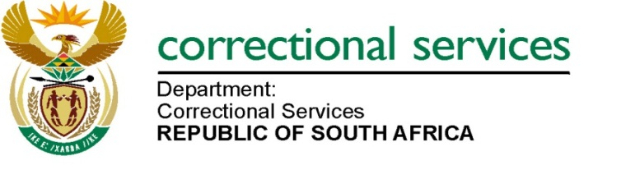
DEPARTMENT OF CORRECTIONAL SERVICES
NEW BID INVITATION
BID NUMBER | DESCRIPTION | PPPFA CRITERIA | PUBLISHING DATE | CLOSING DATE
BID DCS 09/2024 | APPOINTMENT OF A SERVICE PROVIDER (S) FOR SUPPLY, DELIVERY AND OFF-LOADING OF ROUGH SAWN SALIGNA TIMBER SANS 1099:2008 FOR A PERIOD OF THREE (3) YEARS. | 80/20 | 05/09/2024 | 30/09/2024
Notes: Bid documents can also be downloaded for free on http://www.etenders.gov.za/content/advertised-tenders

And http://wwww.dcs.gov.za
- Opportunities-
- tenders bid
- advertised

