NOTICE OF BID INVITATION: DEPARTMENT OF CORRECTIONAL SERVICES
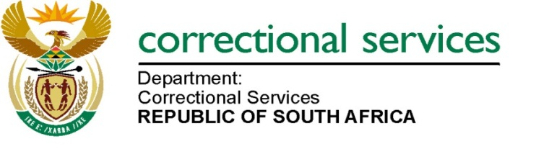
DEPARTMENT OF CORRECTIONAL SERVICES
NEW BID INVITATION
BID NUMBER | DESCRIPTION | PPPFA CRITERIA | PUBLISHING DATE | NON-COMPULSORY BRIEFING SESSION | CLOSING DATE
BID DCS 10/2024 | DCS 10:2024 APPOINTMENT OF A SERVICE PROVIDER (S) FOR SUPPLY, DELIVERY AND OFF-LOADING OF VENEERED MEDIUM DENSITY FIBRE (MDF) AND HIGH-DENSITY FIBRE (HDF) BOARDS SANS 929:2024 TO VARIOUS CORRECTIONAL CENTRES FOR A PERIOD OF THREE (3) YEARS. | 80/20 | 20/11/2024 | 02 December 2024 at 10:00 AM to 11:00 am | 11/12/2024
Contact details: 012 305 8720

A non-compulsory virtual briefing session will be held via Microsoft Teams on 02 December 2024 at 10h00 am to 11h00 am.

Venue: Microsoft Teams
Teams link: https://teams.microsoft.com/l/meetup-join/19%3ameeting_YTBhMzAzZmItYTM0NS00NTIwLTkxMjUtZWFlMmJkZDM3Y2Jm%40thread.v2/0?context=%7b%22Tid%22%3a%2268026d69-ab70-4d46-a3e0-6edad467e5fd%22%2c%22Oid%22%3a%2287df79e8-f410-4d78-ad5f-aa9e38baa645%22%7d

Meeting ID: 373 685 607 218
Passcode: hz9EE9HY
Date: 02 December 2024
Time: 10H00 am to 11H00 am

Notes: Bid documents can also be downloaded for free on http://www.etenders.gov.za/content/advertised-tenders

And http://wwww.dcs.gov.za
- Opportunities-
- tenders bid
- advertised

