NOTICE OF BID INVITATION: DEPARTMENT OF CORRECTIONAL SERVICES
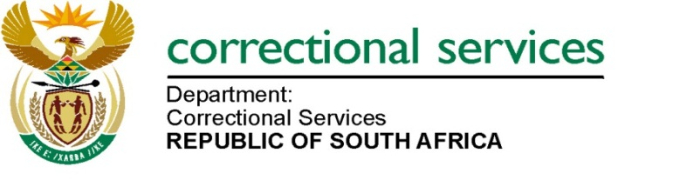
DEPARTMENT OF CORRECTIONAL SERVICES
NEW BID INVITATION
BID NUMBER | DESCRIPTION | PPPFA CRITERIA | PUBLISHING DATE | COMPULSORY BRIEFING SESSION | CLOSING DATE
GTC 01/2024 | APPOINTMENT OF A SERVICE PROVIDER FOR CLEANING SERVICES AND THE PROVISION OF CLEANING MATERIALS TO THE DEPARTMENT OF CORRECTIONAL SERVICES AT FORUM EAST BUILDING, 1077 ARCADIA STREET, HATFIELD FOR A PERIOD OF THREE (3) YEARS. | 80/20 | 10September 2024 | 15 February 2023 at 11:00 AM  Bidders wishing to do a non-compulsory visit may make arrangements with the following officials:  1. Mr. Lepena Mokganyetsi, email: Lepena@Mokganyetsi@dcs.gov.za  2. Mr. Ronnie Nkotswe, email: Ronnie.RonnieNkotswe@dcs.gov.za | 03 October 2024

