NOTICE OF BID INVITATION: DEPARTMENT OF CORRECTIONAL SERVICES
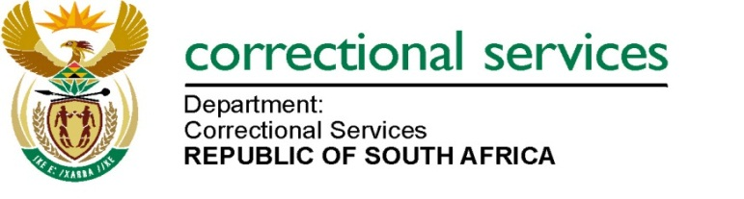
DEPARTMENT OF CORRECTIONAL SERVICES
NEW BID INVITATION
BID NUMBER | DESCRIPTION | PPPFA CRITERIA | PUBLISHING DATE | COMPULSORY BRIEFING SESSION | CLOSING DATE
BID HO4/2025 | APPOINTMENT OF A PANEL OF SERVICE PROVIDERS FOR THE SUPPLY, DELIVERY AND OFF LOADING OF MATTRESSES AT THE DEPARTMENT OF CORRECTIONL SERVICES FOR A PERIOD OF FIVE (5) YEARS | 80/20 | 12/12/2025 | 03 February 2026 at 11:00 AM  Venue: Teams/Virtual | 16/02/2026
BID HO4/2025 | Contact details: 012 307 2121  COMPULSORY BRIEFING SESSION  Bidders must take note of the compulsory briefing session that will take place on 03 February 2026 at 11:00 am. The compulsory briefing session will be held via Teams/Virtual: Department of Correctional Services. Please refer to BD 2.1 for further information regarding this meeting  Notes: Bid documents can also be downloaded for free on http://www.etenders.gov.za/content/advertised-tenders  And http://wwww.dcs.gov.za  - Opportunities-  - tenders bid  - advertised

