NOTICE OF BID INVITATION: DEPARTMENT OF CORRECTIONAL SERVICES
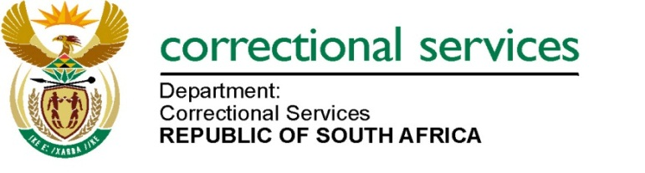
DEPARTMENT OF CORRECTIONAL SERVICES
NEW BID INVITATION
BID NUMBER | DESCRIPTION | PPPFA CRITERIA | PUBLISHING DATE | COMPULSORY BRIEFING SESSION | CLOSING DATE
BID HO 10/2025 | HO 10/2025: APPOINTMENT OF A SERVICE PROVIDER(S) FOR SUPPLY, DELIVERY AND OFF-LOADING OF POINT OF LAYER HENS TO VARIOUS CORRECTIONAL CENTRE FARMS FOR A PERIOD OF THREE (3) YEARS. | 80/20 | 2025/11/24 | N/A | 2025/12/15
BID HO 10/2025 | Contact details: 012 305 8720  A non-compulsory virtual briefing session will be held via Microsoft Teams on 02 December 2024 at 10h00 am to 11h00 am.  Venue: Microsoft Teams  Teams link: https://teams.microsoft.com/l/meetup-join/19%3ameeting_YTBhMzAzZmItYTM0NS00NTIwLTkxMjUtZWFlMmJkZDM3Y2Jm%40thread.v2/0?context=%7b%22Tid%22%3a%2268026d69-ab70-4d46-a3e0-6edad467e5fd%22%2c%22Oid%22%3a%2287df79e8-f410-4d78-ad5f-aa9e38baa645%22%7d  Meeting ID: 373 685 607 218  Passcode: hz9EE9HY  Date: 02 December 2024  Time: 10H00 am to 11H00 am  Notes: Bid documents can also be downloaded for free on http://www.etenders.gov.za/content/advertised-tenders  And http://wwww.dcs.gov.za  - Opportunities-  - tenders bid  - advertised

